**Task 1:**

From the file AdventureWorksCustomers.xlsx, ensure:

* CustomerID is changed to **Text** type
* DateOfBirth is changed to **Date** type

**Task 2:**In the file AdventureWorksProducts.xlsx, replace the word **"Mountain"** with **"MTN"** in the ProductName column.

**Task 3:**

In the AdventureWorksCustomers.xlsx file, split the full name into first and last name using space as a delimiter.

**Task 4:**Format the Email column from the same customer file to:

* Lowercase
* Trim whitespace
* Remove non-printable character

**Task 5:**

From the AdventureWorksProducts.xlsx file, extract:

* First 5 characters
* Text after hyphen (-)

**Task 1:**

From the file AdventureWorksCustomers.xlsx, ensure:

* CustomerID is changed to **Text** type
* DateOfBirth is changed to **Date** type

Before :-

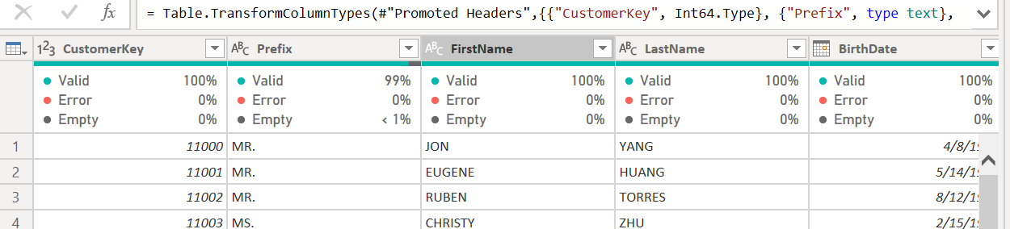

After:  
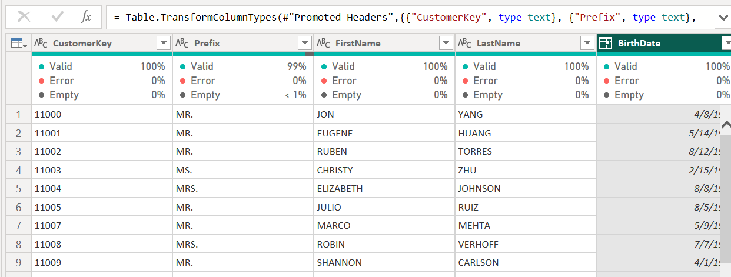

**Task 2:**In the file AdventureWorksProducts.xlsx, replace the word **"Mountain"** with **"MTN"** in the ProductName column.

Before:-

After :-

**Task 3:**

In the AdventureWorksCustomers.xlsx file, split the full name into first and last name using space as a delimiter.

Already data is separated by first name, last name.  
  
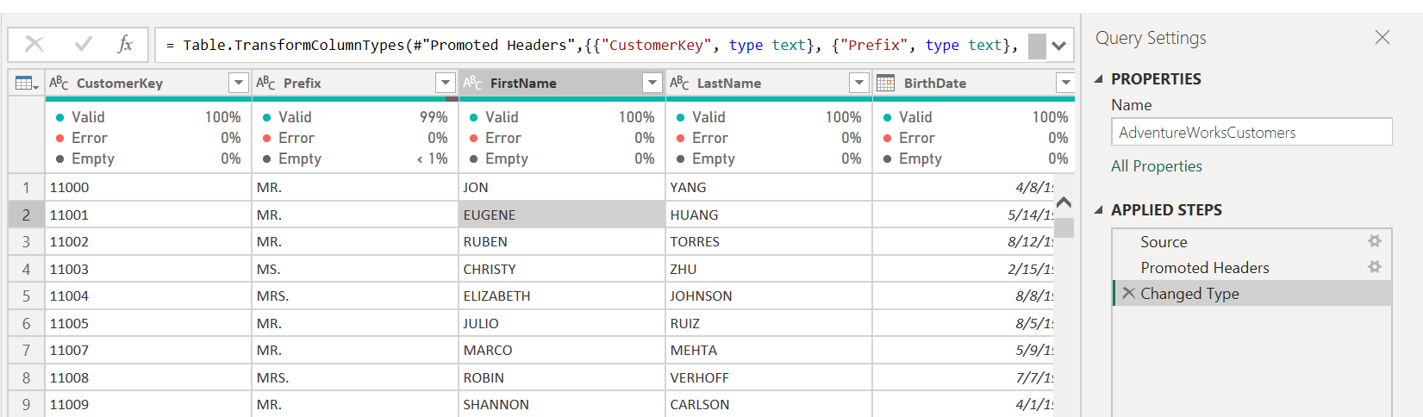

**Task 4:**Format the Email column from the same customer file to:

* Lowercase
* Trim whitespace
* Remove non-printable character

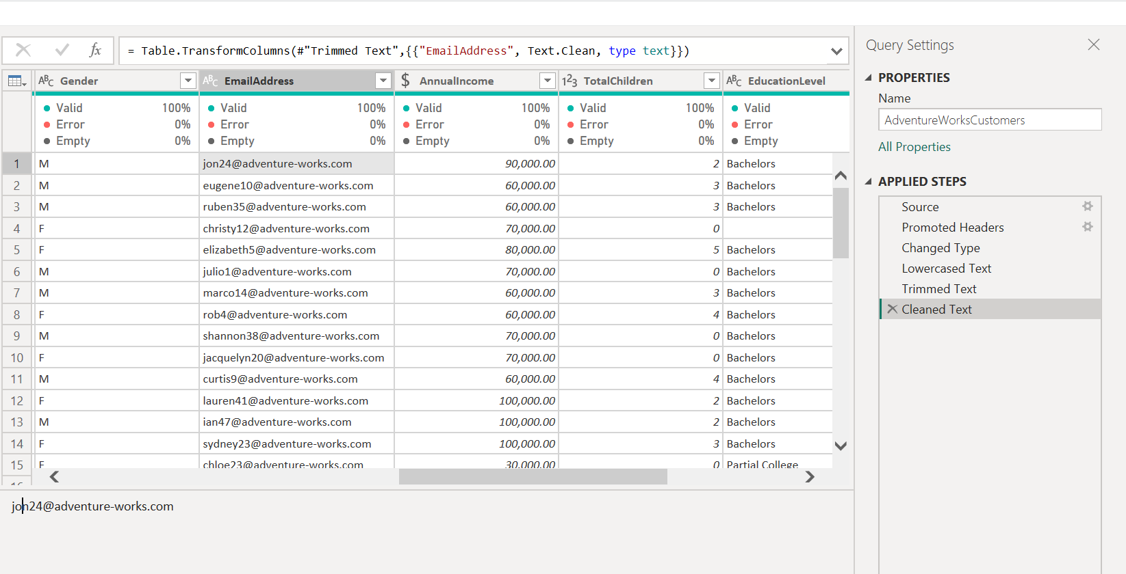

**Task 5:**

From the AdventureWorksProducts.xlsx file, extract:

* First 5 characters
* Text after hyphen (-)